|  |  |  |  |
| --- | --- | --- | --- |
| **CSC 310: Human Computer Interaction**  **Usability Evaluation Report Template**  ­­­­­­­    **Dated**  **11/01/2020**         |  | | --- | | **Prepared By**  **NAMES: Cason Konzer**  **SIGNATURES:** | | | |
| Brief Description of User | | The participating user within my usability study was a straight 57-year-old Caucasian male with pronouns he, him his. His computer experience is limited, although he is a smart phone user. His experiences with laptops/computers have never been frequent, but he has used these systems before. His occupation is a technician/mechanic for the service station industry. He is the president of a family owned business and contracts to the local Genesee and Oakland counties. He has never used the selected Steam system before this study. Such participant was chosen due to ease of access. (Willing & Local). |

|  |  |
| --- | --- |
| Process Overview |  |

The first step within the step up was to ask the user their overall mood to get a baseline. Following I asked the user to take a brief minute to read over the script.

Script:

          Thank you for agreeing to participate in our university study on interfaces. We are UM Flint students studying Human-Computer Interaction. The system we are demoing is the Steam game platform. The Steam platform is a system that can be used to buy, install, launch and communicate about computer games, as well as with other users. We will be asking you to perform several tasks for this demo.

The first task is to use Steam to purchase a game. Please do the following: Launch the Steam application. Open the Steam store. Search the store for the game we have designated for you (*Destiny 2*). Purchase the game for the demo account.

After purchase follow the instructions provided by Steam and the selected game (*Destiny 2*) to download and install such game (*Destiny 2*) to the provided computer.

Next, you are to use Steam to run a computer game. Assume you would like to play a game. To do so, please do the following: Open the game library. Select or search for the game you would like (*Destiny 2*). Launch the game (*Destiny 2*) from the game’s page in the steam application. Because we are not testing *Destiny 2* itself, please exit the game so we can continue the study.

The following task is to use Steam to add a new friend (Bob) to the user’s friends list. Under the friends tab, click on the “Add a Friend …” button, followed typing Bob in the “Enter your friend’s profile name” search bar. To finish click the “ADD AS FRIEND” button, to the right of Bob, to add Bob as a friend.

  The final task is to use Steam to send another user a text message. Open the Friends window. Select a friend (Bob), send the user (Bob) a message, a simple “Hello Bob” will suffice.

Thank you for your participation. Please answer the questionnaire to assist in our research.

End Script.

After the user has read over the script I take them over to a table with the paper prototype setup with seating for their comfort. Following I ask the user to follow along the script using the paper prototype. In addition I ask the user to try and “think aloud” to express their thoughts. I asked the user what the pros and cons were of each page. At the end of the study I retake a mood rating to see if the experience changed their mood and then had them the questionnaire to fill out.

Questionnaire:

1. Have you ever used a computer before?
   1. If so, how often?
2. Have you ever used Steam?
   1. If so, how often?
3. Have you ever played a computer game before?
   1. If so, how often?
4. Have you ever used a competing platform, such as Origin?
   1. Would you describe the other platform's experience as being better than Steam's?
5. Do you usually run Steam to do a specific task?
6. What is usually the first thing you do when you run Steam?
7. How many games are in your favorites list?
8. Have you ever manually installed an update for a game?
   1. Why did you install the update manually?
9. How do you usually add games to your Steam library?
10. How do you normally communicate with friends while playing a game?
11. What was your most used function of Steam? Why?
12. What was your biggest challenge/obstacle faced during the testing process?
13. Rank Steam experience (1-10)  “1-Terrible & 10-Amazing”
14. Rank *Destiny 2* experience (1-10) “1-Terrible & 10-Amazing”

|  |  |
| --- | --- |
| Transcript | ### = Changes to be made. |

Thanks for participating in the study, how would you rank your mood on a scale from 1-10? (Cason)

No problem, I would say I’m at a 7. (User)

Alrighty thanks, Could you take a minute to read over this script and come to me with any questions? (Cason)

Sure. (User)

*User reads script*

Alrighty I’ve read it through. (User)

Okay would you now come over to the table to perform the test. (Cason)

Yep (User)

So, if you would now try to perform the tasks on the script by using this pen as a pointer on the paper prototype. (Cason)

I will simulate the computer system by performing its actions in paper. (Cason)

If you could please think aloud and explain your though process. (Cason)

Launch Steam Application. (User)

This will be the launched demo page. (Cason) See Picture 1

Purchase the game for the demo account, through the store. Search the store for the game. (User)

*User clicks search*

*Search display changed on paper prototype*

So now pretend you have a keyboard, and you can search for it. (Cason) ###

Destiny 2 (User)

*User “types” in the game name and is looking for a place to search*

Okay so maybe there should be a send button here. (Cason) ###

You can pretend to click enter on the “keyboard.” (Cason)

*Screen Display changed to Destiny 2 in Store* See Picture 2

Destiny 2, just what I was looking for, I want to purchase it…” (User)

So I’m going to click Purchase. (User)

*User clicks purchase*

Bzzzz you’ve now got the game purchased and installed, I should’ve added in an install popup. (Cason) ###

So I own it. (User)

*User select destiny 2 from the Store page*

So that would take you right to the game could you access it through the library? (Cason)

Okay. (User)

*User clicks on Library*

*Screen Display changed to Library* See Picture 3

And you click on Destiny 2. (Cason)

## Again, okay even though it doesn’t say destiny 2. (User) ###

*User clicks Density*

Okay so that loads the game and closes it out. (Cason) ###

Following the task is to add a friend bob. (User)

*User clicks Friends Button*

*Screen Display changed to Friends* See Picture 4

Add a Friend. (User)

I don’t know how to add a friend. (User)

New. (Cason) ###

*Pointing to new the user now clicks new*

*New friend search popup added*

*User “types” Bob and clicks “enter”*

And now you’ve added that friend (Cason)

The final task is to send another user a text message. (User)

I don’t know where to type here. (User)

Message. (Cason) ###

*User clicks on message button*

*User types in bob and clicks enter*

*User types in message content and clicks enter to send*

Before the questionnaire, could you go over your Likes and Dislikes of each page? (Cason).

What were you thinking when on the store page? What was good and what was bad? See Picture 1

Good: new releases; features; not too cluttered. (User Sum.)

Bad: free programs or pricing. (User Sum.) ###

Okay next up the Destiny 2 store page, try to think about the process as well. See Picture 2

Good: it came up after I searched it; the scroll is nice; highlights are nice; nice they have clips (image previews).

Bad: I don’t know how much it costs; devs should be developers; Add in the hacks; No install popups. (User Sum.) ###

Now we’re onto the Library page. (Cason) See Picture 3

Good: Favorites tab, owned tab; Image previews. (User Sum.)

Bad: Destiny should be Destiny 2; It’d be nice if they were alphabetically ordered; have previews represent the favorites. (User Sum.) ###

Next page is the friends Page. (Cason) See Picture 4

Good: N/A

Bad: I don’t know what wave means; New was hard to tell it meant new friend; (User sum.)

Bad: I don’t understand the Arrows; It would be nice if it displayed profile pictures. (User sum.) ###

And now for the inbox. (Cason)

What was the inbox? (User)

Where you send messages. (Cason)

So I don’t even know I’m in Steam, I think it needs a header. (User) ###

Alright so Likes/Dislikes? (Cason)

Good: It shows recent messages; I like the arrow for send; The recent message previews are nice. (User sum.)

Bad: New was hard to understand; I might not understand how you’re supposed to type where it says content. (User sum.) ###

Alrighty, so how is your mood now out of 10 now? (Cason)

7.2 (User)

Thanks again, would you be willing to fill out this final questionnaire? (Cason)

Sure. (User)

\/\/ *USER FILLS OUT QUESTIONNAIRE* \/\/

1. Have you ever used a computer before? YES
   1. If so, how often? EVERY OTHER WEEK
2. Have you ever used Steam? NO
   1. If so, how often? N/A
3. Have you ever played a computer game before? YES
   1. If so, how often? 4-TIMES/YEAR
4. Have you ever used a competing platform, such as Origin? NO
   1. Would you describe the other platform's experience as being better than Steam's? N/A
5. Do you usually run Steam to do a specific task? N/A
6. What is usually the first thing you do when you run Steam? N/A
7. How many games are in your favorites list? N/A
8. Have you ever manually installed an update for a game? YES
   1. Why did you install the update manually? NOT A FAN OF AUTO-UPDATES
9. How do you usually add games to your Steam library? N/A
10. How do you normally communicate with friends while playing a game? N/A
11. What was your most used function of Steam? Why? N/A
12. What was your biggest challenge/obstacle faced during the testing process? NOT ACTUALLY USING A COMPUTER
13. Rank Steam experience (1-10)  “1-Terrible & 10-Amazing” 2
14. Rank *Destiny 2* experience (1-10) “1-Terrible & 10-Amazing” N/A

Well look at that your mood even increased. (Cason)

Yep you were patient. (User)

|  |  |
| --- | --- |
| Feedback & Critical Incidence | Description of columns in the table are as follows:  *Prototype Screen/Page:*  Which screen of the user interface the user was evaluating at the point of feedback/critical incidence/problem.  *Reference:*  This column should be used to relate an item back to a specific point in the session. The reference can be to a specific line number in the transcript above or a time code.  *User feedback / critical incidence / problem:*  This column may contain :   * Feedback (positive or negative) given by the users, **or** * Critical incidences (breakdowns or problems encountered by users) and/or mistakes committed by users.   *Reason for negative feedback / breakdown:*  Briefly explain the reason for a breakdown or any negative feedback.  *Scope:*  Describe the scope of the feedback or the problem; include whether the scope of the issue is throughout the system/device or within a specific screen or screens. If the problems are specific to a page, include the appropriate page reference.  *Severity (H/M/L) :*  Your assessment as to whether the implication of the feedback is *low*, *medium*, or *high* severity, and the **justification** for that rating.    *Way(s) to rectify:*  Suggestion for the modifications that might be made to the user interface to address the issue or issues in this row. You MUST include trade-offs to be credible. If you can’t think of some bad trade-off, say so. |

##### **Usability Evaluation Feedback Analysis**

|  |  |  |  |  |  |  |  |
| --- | --- | --- | --- | --- | --- | --- | --- |
| **#**  # | **Prototype Screen** | **Reference** | **User’s feedback/ critical incidence/ problem** | **Reason for negative feedback / breakdown** | **Scope** | **Severity**  (High/ Medium/ Low) and **Justification** for giving that rating | **Way(s) to rectify and any Tradeoffs (i.e., why the fix might not work)** |
| 1 | See Picture 1 | 56 | Would like to see free games and pricing. | No displayed free or pricing tags. | Through the whole Steam store. | High. Pricing is one of the largest deciding factors when users are looking for new games to play. | Add a price indicator on the game previews and in the game page within the Steam store. |
| 2 | See Picture 2 | 26,27, 59, 90 | No Installation popup.  Devs should be developers | User was not sure if the game had been downloaded/ installed.  User did not know what devs was abbreviating. | Strictly acquiring new games. | Medium, The user was quick to move on but does not like automatic installation.  Low. Most users don’t care about the developers. | Add in an installer popup with a progress menu and a cancel option.  Change devs to developers. |
| 3 | See Picture 3 | 34,36, 62 | It says Destiny,  How do I know if I’m in the game?  Previews do not match featured games | Destiny was suppose to say Destiny 2.  No game popup.  Previews were of random games. | Strictly when playing installed games.  Looking for new games. | Medium. User was unsure if they could move onto the next task or if the game ran.  Low. Previews were of different games to ponder. | Add a 2 after destiny.  Add a Destiny 2 popup with a “Playing” display and a close option.  Sync previews with featured games. |
| 4 | See Picture 4 | 41,42 | I don’t know how to add a friend. | The button for adding a friend simply said new. | Strictly when adding new friends. | Medium. Although there was a new button in the friends tab, the user could not figure out how to proceed. | Change the New button to an equivalent Add, New Friend, or Add Friend.  I weigh the Add Friend option as most relevant because it seems the most clear. |
| 5 | See Picture 4 | 48,49, 66 | I don’t know where to type here.  Would be nice to have Profile Pictures.  The arrows don’t make sense here. | User must first click Message before they can type.  No current profile pictures.  Arrows did not do any cycling | Strictly when messaging a User from the friends’ screen or looking for friends | Medium. Although there was a message button in the friends’ tab, the user could not figure out how to proceed.  Low. Profile pics and arrows are not necessary. | Change the message button to a new equivalent new message button for clarity.  Add in user images.  Remove unnecessary arrows. |
| 6 | ALL | 17,20, 62 | No physical or paper keyboard. No send button for searches.  Text would be easier to follow if it was Alpha. Ordered. | User was confused on how to use the search feature.  No current text ordering schema. | Whole Testing Experience. | Low; we were able to continue the test with an imaginary keyboard. Medium; no search button, user must figure out clicking enter on the keyboard. | Either print a paper keyboard to use with the testing or provide the user with a physical keyboard.  Implementation of a send button following the text field for searches. |

Picture 1:



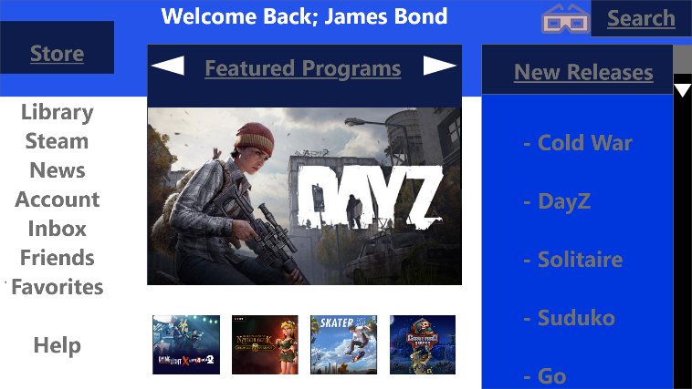

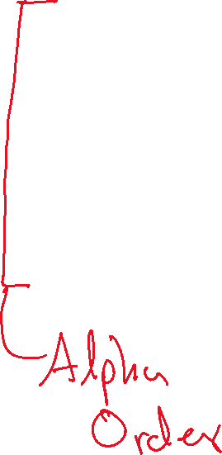

Picture 2:

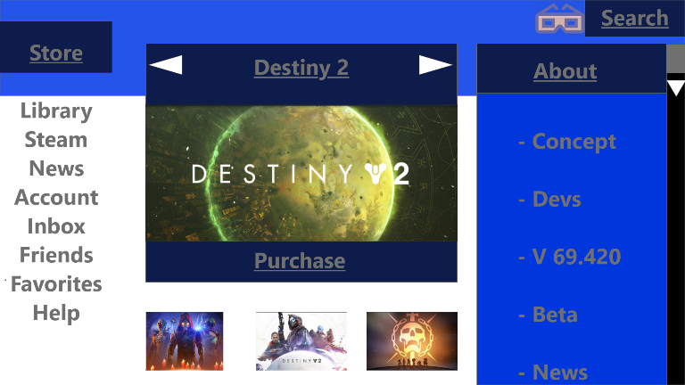



Picture 3:

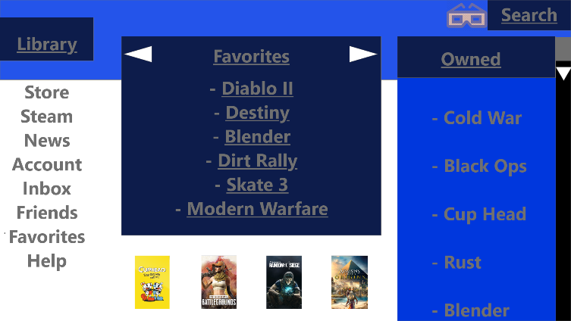

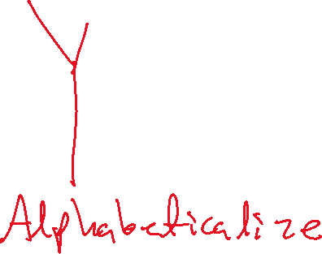

Picture 4:

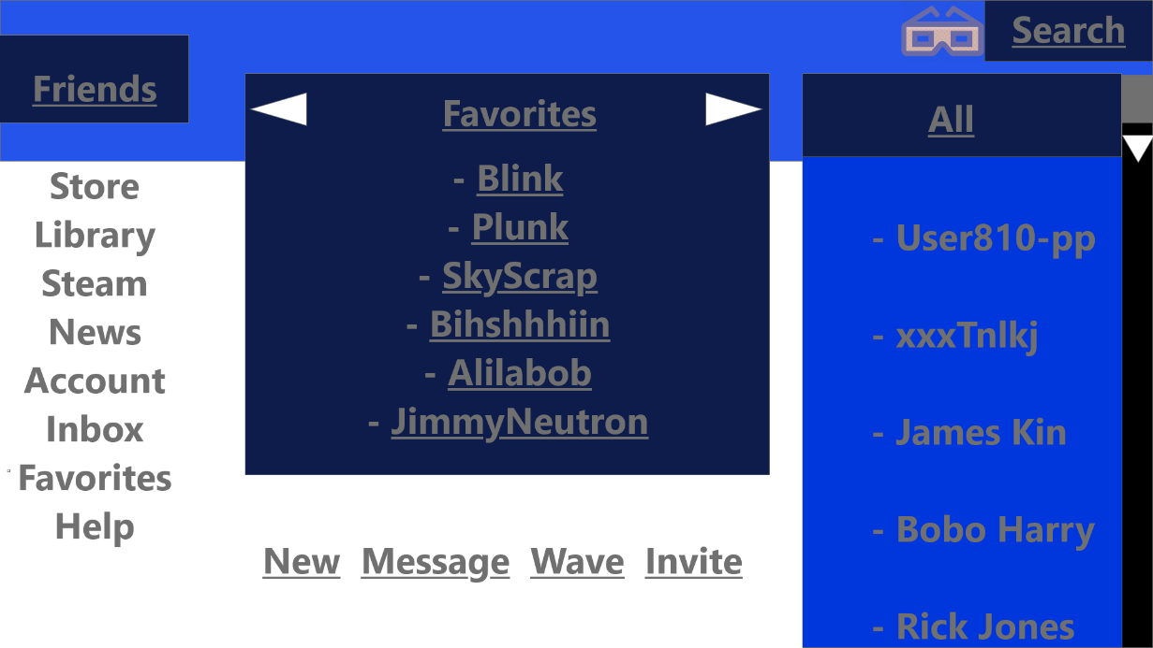

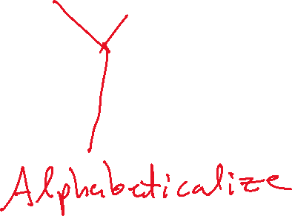

Picture 5:

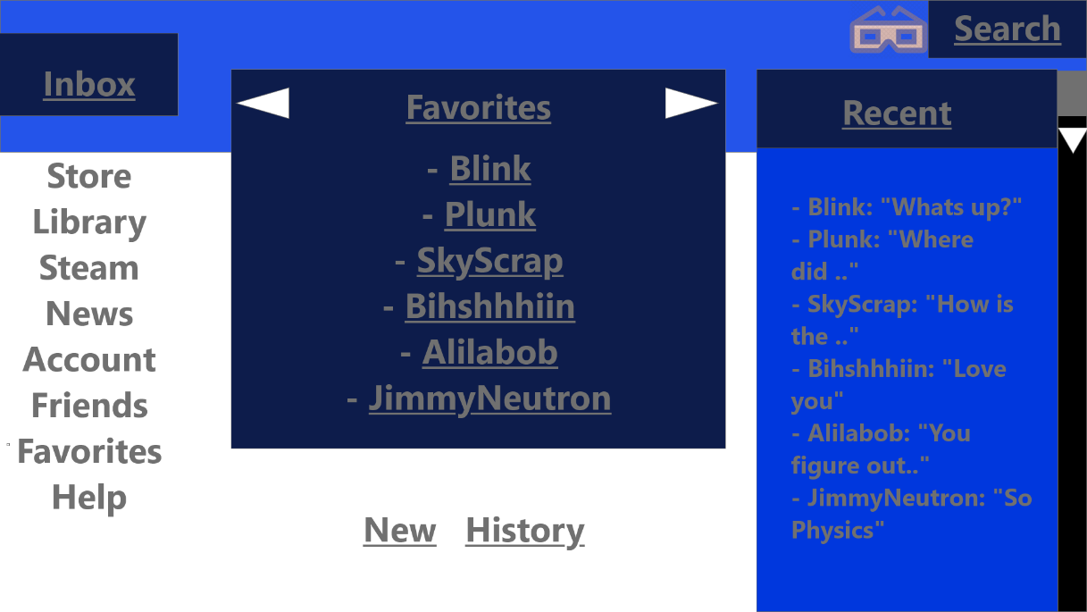

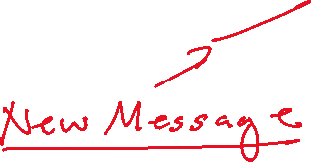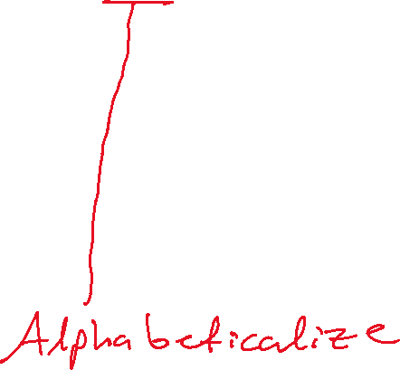

Picture 6:



